**AL-IHSAN ACADEMY**

Review Sheet. ( Physical Science)

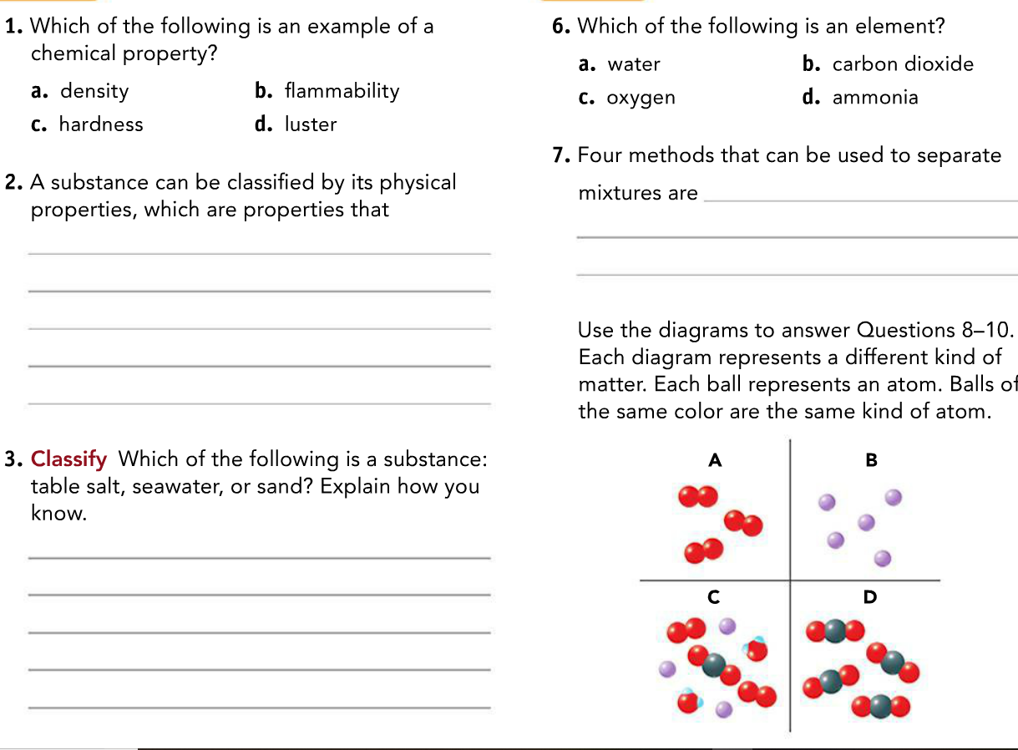

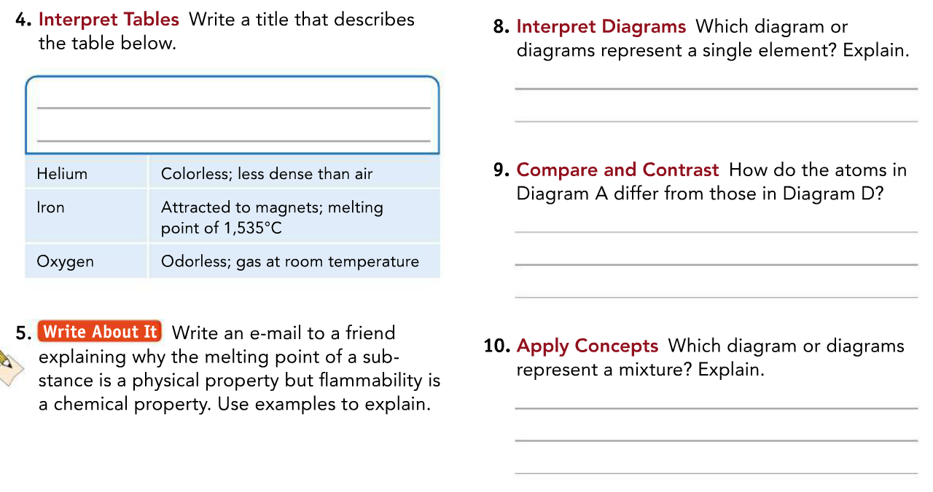

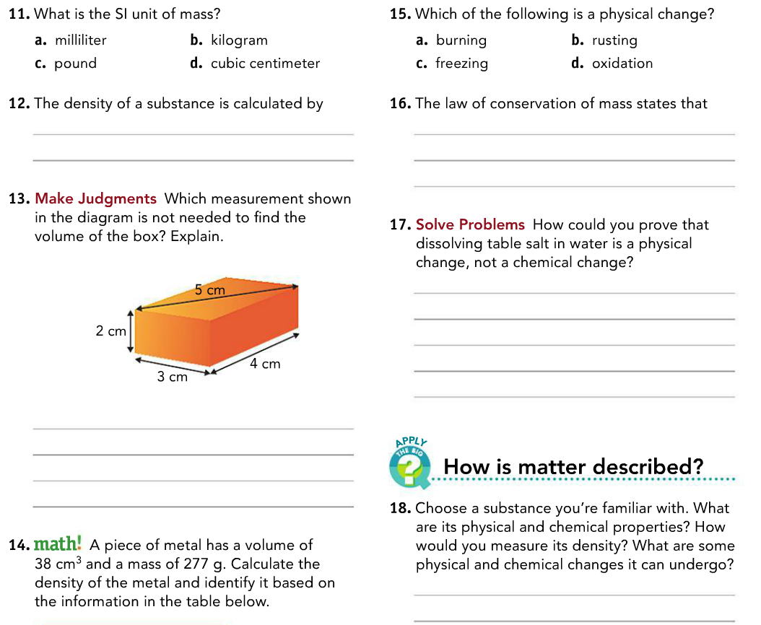

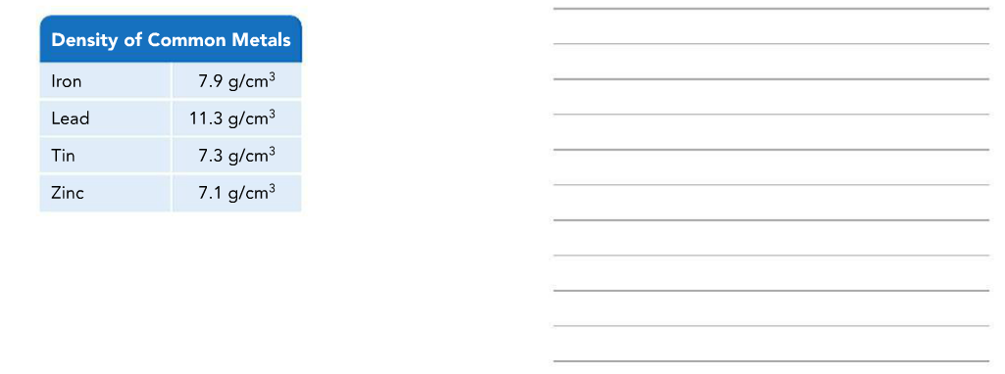

Section: 2

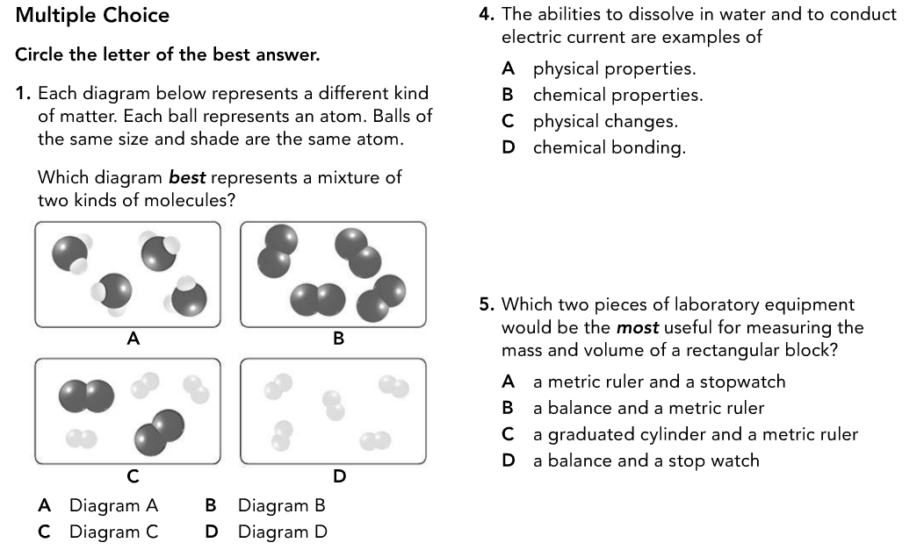

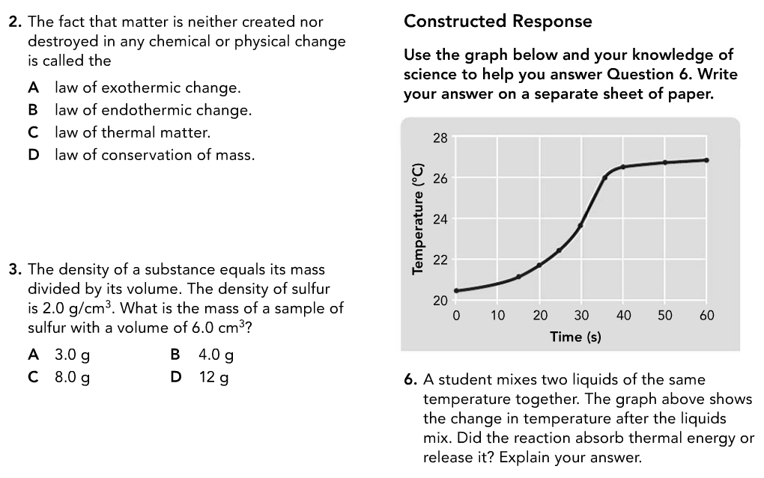

Section: 3

1. Define the below Terms:
2. Matter
3. Chemistry
4. Substance
5. Physical property
6. Chemical property
7. What two properties are used to classify matter?
8. What are the three (3) states of matter?
9. Recall definitions and answer the below:
10. A substance that cannot be broken down into any other substances by chemical or physical means is called ……………………………….?
11. The basic particle from which all elements are made is called ………………………………….?
12. The force of attraction between two atoms is called …………………………?

d) When a group of two or more atoms are held together by a chemical bond, this is called a …………………………. ?

e)A substance made of two or more elements that are chemically combined in a set ratio is called …………………………..?

1. The type of formula that shows the elements in the compound and the combining ratios of their atoms is called ………………………………….?
2. When two or more substances that are together in the same place BUT whose atoms are NOT chemically bonded or combined is called …………………………………………..?
3. A type of mixture where the different parts can usually be seen and easily separated is called ……………………….?
4. A type of mixture where the parts CANNOT be seen or separated easily is called ………………………
5. Recall definitions and answer the below:
6. The measure of the force of gravity on an object is called …………………………….?
7. The amount of matter that an object is made up of is called………………………………..?
8. To measure the properties of matter, scientists use a system called ………………………………..?
9. The amount of space matter occupies is called ……………………………..?
10. The measure of the mass of a material in a given volume is called ………………………………?
11. What is the density of water?
12. The four methods discussed in your book to separate mixtures are Filtration, distillation, evaporation and ………………………………..?
13. Recall definitions and answer the below:
14. The fact that matter is not created or destroyed in any chemical or physical change is called ……………………………………?
15. The measure of how hot or cold something is called……………………………….?
16. The total energy of all the particles in an object is called…………………………………?
17. A change in which energy is absorbed is called…………………………….?
18. A change in which energy is released is called …………………………………?
19. The energy stored in the chemical bonds between atoms is called ………………………………?